COUNCIL DELEGATES & OFFICERS PRESENT: Eric Tieszen, Michael White, Dick Dawson, Larry Nebelsick, Jeff Scott, Sarah Woltzen, Katie and Ivan Ortman, Doreen Fry, Gayle Janzen and Karyn Montgomery. A Quorum Was Present
COUNCIL DELEGATES & OFFICERS ABSENT: Lindsey Mehlbrech and Carol Woltzen
ELDERS PRESENT:
ALTERNATES PRESENT: Sarah Woltzen
STAFF PRESENT:
VISITORS:
MODERATOR: Rev. Jerry Bertelson
MEETING CALLED TO ORDER: Cody Church
DEVOTION AND OPENING PRAYER: Cody Church

*APPROVAL OF AGENDA: Larry Nebelsick made a motion to approve the February 27, 2022, agenda as printed. Eric Tieszen seconded the motion. Council VOTED and approved the agenda.

*APPROVAL OF MINUTES: Jeff Scott made a motion to approve the January 30, 2022, minutes as printed. Ivan Ortman seconded the motion. Council VOTED and approved the minutes.

UNFINISHED BUSINESS: delegates and alternates from a few committees

TRUSTEES: no report

STEWARDSHIP AND FINANCE: Finance has a meeting scheduled for Sunday March 6 after church. Audit was completed on February 22.
FUND | Jan. 1, 2022  BALANCE | DEPOSITS | DISBURSEMENTS | Jan 31, 2022  BALANCE
General Fund | 217,679.24 |  |  | 215,118.11
Capital Improvement | 12,065.51 |  |  | 12,065.51
Special Services | 10,070.46 |  |  | 10,120.46
Music-Choir Fund | 124.25 |  |  | 124.25
Scholarship Fund | 40,737.53 |  |  | 40,737.53
Riverside Cemetery | 11,646.11 |  |  | 11,646.11
Memorial Funds
Undesignated | 8826.71 |  |  | 8826.71
Library | 311.60 |  |  | 311.60
Music | 2065.15 |  |  | 2065.15
cd #4878 | 4631.38 |  |  | 4631.38
Horse Camp | 5068.37 |  |  | 5068.37
TOTAL MEMORIAL FUNDS | 20903.21 |  |  | 20903.21
riverside cemetery upkeep | 992.89 |  |  | 992.89

CHRISTIAN EDUCATION: no report

WORSHIP AND MEMBERSHIP: no report

PASTORAL RELATIONS:
PPR meeting
Pastor’s office
February 6, 2022

A PPR meeting was held after church on February 6, 2022, to discuss Pastor Jerry serving as a consultant for the Good Samaritan Society. As Jerry explained, he would serve on a leadership team that would help a growing population of baby boomers as they age and start making decisions about nursing homes and extended care. The time commitment would be one day a week attendance (which would be his day off) as well as other times in the evenings done remotely from his home.

We felt that it is an excellent opportunity for professional growth for our church generationally as our membership continues to age. Pastor Jerry is first and foremost committed to our church and his responsibilities here.

The first 6 months would be a trial to make sure that it is not an overwhelming time commitment.

Larry Nebelsick
PPR Chair

WORLD OUTREACH: no report

UWS: no report

MEMBER AT LARGE: no report

ELDERS: no report
COMMISSIONER TO PRESBYTERY: 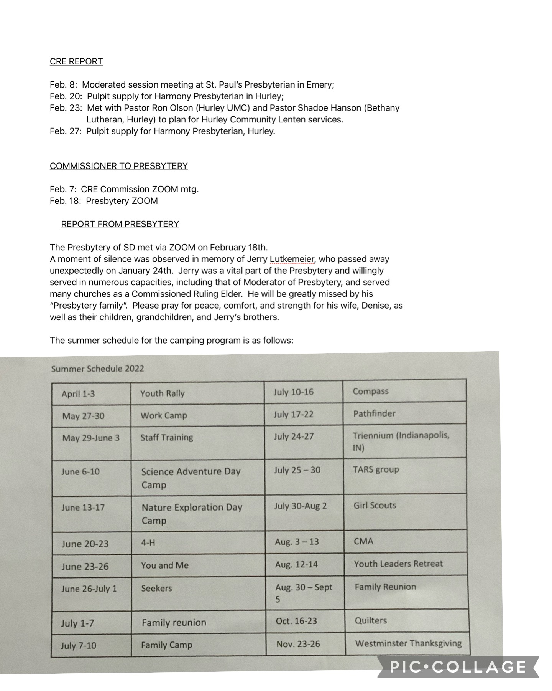
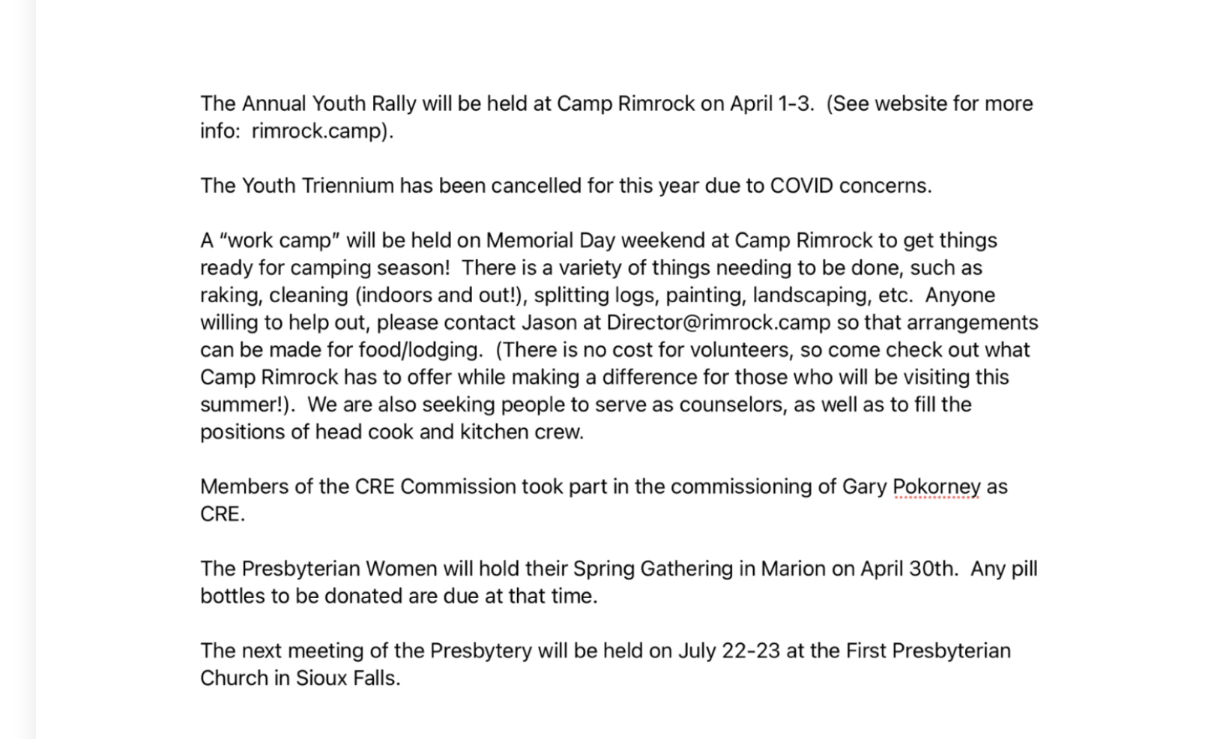
LAY MEMBER TO ANNUAL CONFERENCE: no report

EXPLORATORY COMMITTEE: no report

PASTOR’S REPORT:
February 2022

Cold weather is upon this past week, but I look forward to the warmth of this summer, especially the times that the youth and I and a group of chaperones will be heading to Los Angeles for a summer mission trip. The dates are May 30 – June 6. If any other congregation members, in addition to the high school youth, would like to attend, please speak to Pastor Jerry. Seats are still available!

Below are a few notes from the past month of ministry:

- Hosted communion at the nursing home in Canistota on February 8. A total of 13 individuals were served.
- Participated in a SD Presbytery MDE call on February 18. Welcomed a new Commissioned ruling Elder into the Presbytery.
- Met with District Superintendent, Rev. Rebecca Trefz, from the Dakotas UMC Conference on February 8th. I will be meeting with the Dakotas UMC soon to receive ordination recognition with the denomination.
- Finished the God in America video discussion on February 2. Looking to host another Wed. night series soon.
- Participated as a panelist in an Intro. To Ministry class at the University of Sioux Falls on February 25.
- Hosted Confirmation meetings on February 9th and 23rd for confirmands.
- Participated in two continuing education events – Spiritual Enrichment book discussion with the Benedictine Sisters in Yankton and the Faith Leadership Seminar at the Bowen Study Center at Georgetown University.
- Attended a Ministers Council board retreat in North Carolina on February 14-17. Paid for by the American Baptist Ministers Council.
- Delivered food pantry items to McCook Food Pantry on February 10th.
- Attended a pastor’s luncheon at Hope Haven in Parker on February 24th. I encourage the Mission Committee to find ways for our church to support this local ministry.
- Completed a sermon series on Christianity & the World’s Religions and a second on Stages of Faith Development called The Critical Journey. Beginning a new five-part series in March on the spiritual disciplines based on Richard Foster’s classic book Celebration of Discipline.
- Confirmation banquet will be on May 21st at 5 pm. Confirmation Sunday will be May 22nd.
- Continued with typical pastoral duties of home visits (limited currently due to illnesses in the community), phone calls, texts/emails, preaching, teaching, and leading worship.
- A special thank you to Mandy Keller for facilitating the pizza fundraiser this year. The youth sold over 600 pizzas in January!

Coming up:
- New member Sunday (TBD)
- Ash Wednesday on March 2 at 7 pm
- Lenten book study in lieu of Lenten services. Personal study on Dr. Hiigel’s book, Partnering with the King. Group discussion hosted on April 16th at 5:00 pm.

Respectfully submitted,
Pastor Jerry

APPROVAL OF COMMITTEE REPORTS: Gayle Janzen made a motion to approve the committee reports. Dick Dawson seconded the motion; Council VOTED and approved the reports.

NEW BUSINESS:

NEXT MEETING: March 27,2022 at 7:30 PM Worship and Membership will have opening devotions.

ADJOURNMENT: Larry Nebelsick made a motion to adjourn. Jeff Scott seconded the motion, Council VOTED and adjourned.

CLOSING PRAYER: Cody Church

CLERK_____________________________________

_______________________________________DATE

