COUNCIL DELEGATES & OFFICERS PRESENT: A Quorum Was Present
COUNCIL DELEGATES & OFFICERS ABSENT:
ELDERS PRESENT:
ALTERNATES PRESENT:
STAFF PRESENT:
VISITORS:
MODERATOR:
MEETING CALLED TO ORDER:
DEVOTION AND OPENING PRAYER:

*APPROVAL OF AGENDA: _____________ made a motion to approve the February 27, 2022, agenda as printed. _____________ seconded the motion. Council VOTED and approved the agenda.

*APPROVAL OF MINUTES: _________________made a motion to approve the January 30, 2022, minutes as printed. ________ seconded the motion. Council VOTED and approved the minutes.

UNFINISHED BUSINESS: delegates and alternates from a few committees

TRUSTEES: no report

STEWARDSHIP AND FINANCE: Finance has a meeting scheduled for Sunday March 6 after church. Audit was completed on February 22.
FUND | Jan. 1, 2022  BALANCE | DEPOSITS | DISBURSEMENTS | Jan 31, 2022  BALANCE
General Fund | 217,679.24 |  |  | 215,118.11
Capital Improvement | 12,065.51 |  |  | 12,065.51
Special Services | 10,070.46 |  |  | 10,120.46
Music-Choir Fund | 124.25 |  |  | 124.25
Scholarship Fund | 40,737.53 |  |  | 40,737.53
Riverside Cemetery | 11,646.11 |  |  | 11,646.11
Memorial Funds
Undesignated | 8826.71 |  |  | 8826.71
Library | 311.60 |  |  | 311.60
Music | 2065.15 |  |  | 2065.15
cd #4878 | 4631.38 |  |  | 4631.38
Horse Camp | 5068.37 |  |  | 5068.37
TOTAL MEMORIAL FUNDS | 20903.21 |  |  | 20903.21
riverside cemetery upkeep | 992.89 |  |  | 992.89

CHRISTIAN EDUCATION: no report

WORSHIP AND MEMBERSHIP: no report

PASTORAL RELATIONS: no report

WORLD OUTREACH: no report

UWS: no report

MEMBER AT LARGE: no report
ELDERS: no report

COMMISSIONER TO PRESBYTERY: 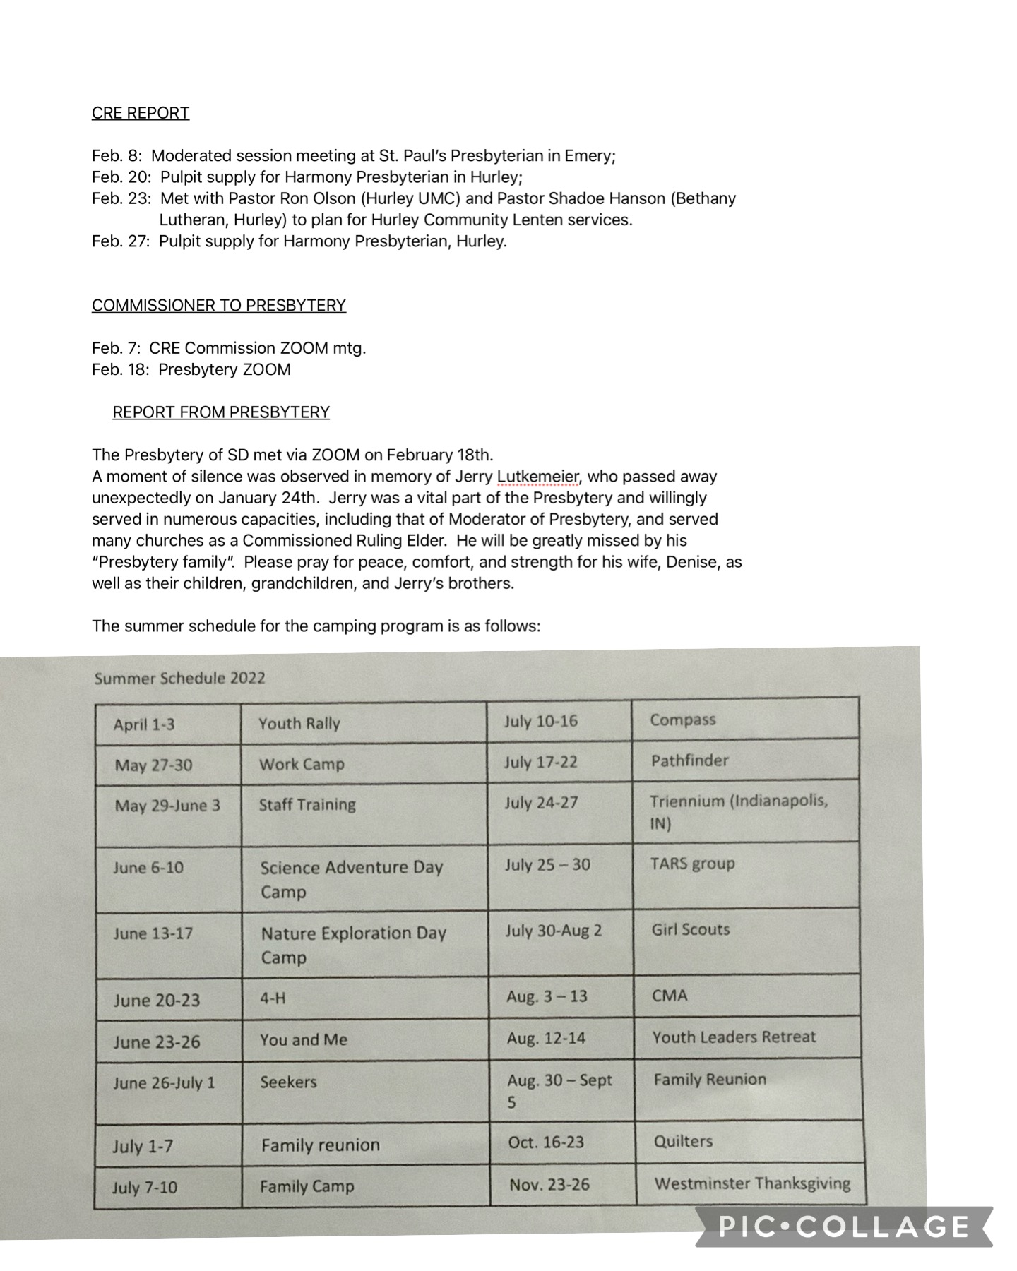
LAY MEMBER TO ANNUAL CONFERENCE: no report

EXPLORATORY COMMITTEE: no report

PASTOR’S REPORT:
February 2022

Cold weather is upon this past week, but I look forward to the warmth of this summer, especially the times that the youth and I and a group of chaperones will be heading to Los Angeles for a summer mission trip. The dates are May 30 – June 6. If any other congregation members, in addition to the high school youth, would like to attend, please speak to Pastor Jerry. Seats are still available!

Below are a few notes from the past month of ministry:

- Hosted communion at the nursing home in Canistota on February 8. A total of 13 individuals were served.
- Participated in a SD Presbytery MDE call on February 18. Welcomed a new Commissioned ruling Elder into the Presbytery.
- Met with District Superintendent, Rev. Rebecca Trefz, from the Dakotas UMC Conference on February 8th. I will be meeting with the Dakotas UMC soon to receive ordination recognition with the denomination.
- Finished the God in America video discussion on February 2. Looking to host another Wed. night series soon.
- Participated as a panelist in an Intro. To Ministry class at the University of Sioux Falls on February 25.
- Hosted Confirmation meetings on February 9th and 23rd for confirmands.
- Participated in two continuing education events – Spiritual Enrichment book discussion with the Benedictine Sisters in Yankton and the Faith Leadership Seminar at the Bowen Study Center at Georgetown University.
- Attended a Ministers Council board retreat in North Carolina on February 14-17. Paid for by the American Baptist Ministers Council.
- Delivered food pantry items to McCook Food Pantry on February 10th.
- Attended a pastor’s luncheon at Hope Haven in Parker on February 24th. I encourage the Mission Committee to find ways for our church to support this local ministry.
- Completed a sermon series on Christianity & the World’s Religions and a second on Stages of Faith Development called The Critical Journey. Beginning a new five-part series in March on the spiritual disciplines based on Richard Foster’s classic book Celebration of Discipline.
- Confirmation banquet will be on May 21st at 5 pm. Confirmation Sunday will be May 22nd.
- Continued with typical pastoral duties of home visits (limited currently due to illnesses in the community), phone calls, texts/emails, preaching, teaching, and leading worship.
- A special thank you to Mandy Keller for facilitating the pizza fundraiser this year. The youth sold over 600 pizzas in January!

Coming up:
- New member Sunday (TBD)
- Ash Wednesday on March 2 at 7 pm
- Lenten book study in lieu of Lenten services. Personal study on Dr. Hiigel’s book, Partnering with the King. Group discussion hosted on April 16th at 5:00 pm.

Respectfully submitted,
Pastor Jerry

APPROVAL OF COMMITTEE REPORTS: ______________ made a motion to approve the committee reports. ___________ seconded the motion, Council VOTED and approved the reports.

NEW BUSINESS:

NEXT MEETING: ___________________ at 7:30 PM __________________will have opening devotions.

ADJOURNMENT: __________________ made a motion to adjourn. __________________ seconded the motion, Council VOTED and adjourned.

CLOSING PRAYER: ____________________

CLERK_____________________________________

_______________________________________DATE

